**Salt Lake City Downtown Map**

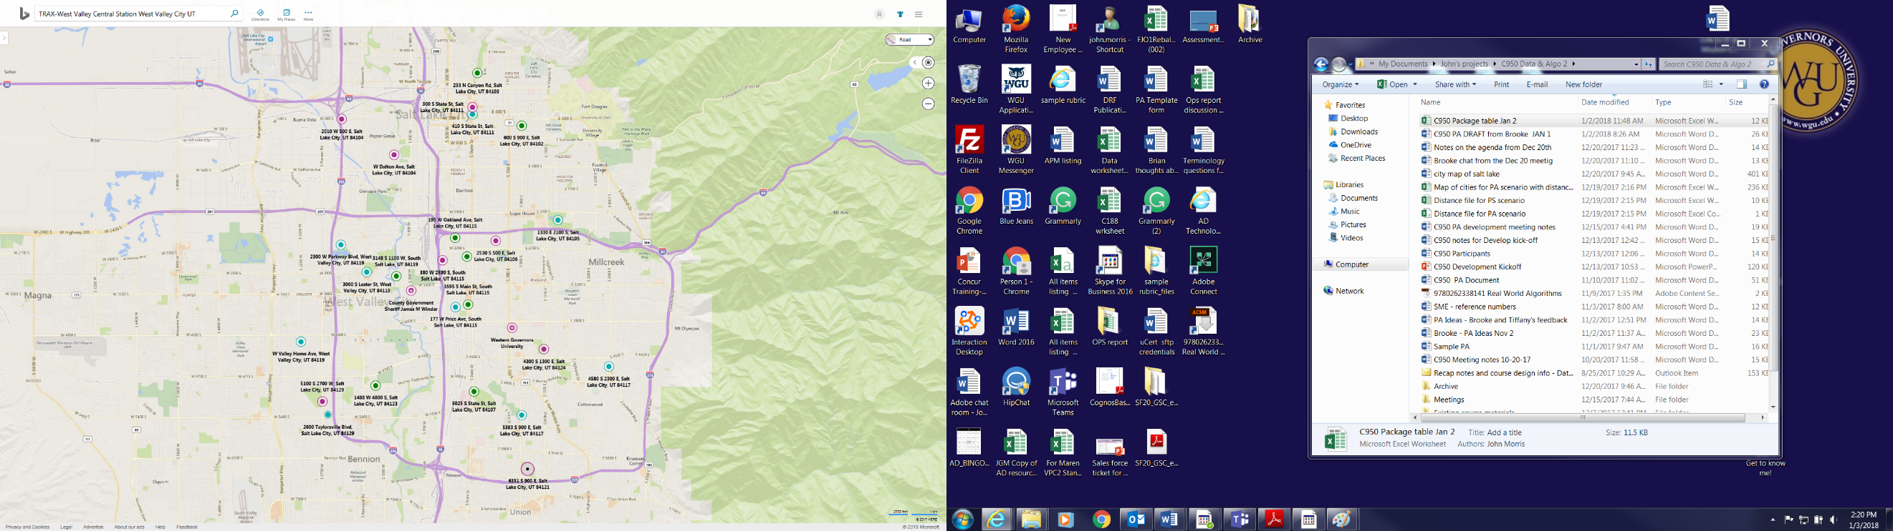

20,13,14,15,16,19



Pass once, drop 19 - EOTrip

14,13,15,16,19



13

13,15,16,19

